Example: Global Abstract classes
Abstract class: z1030restaurant
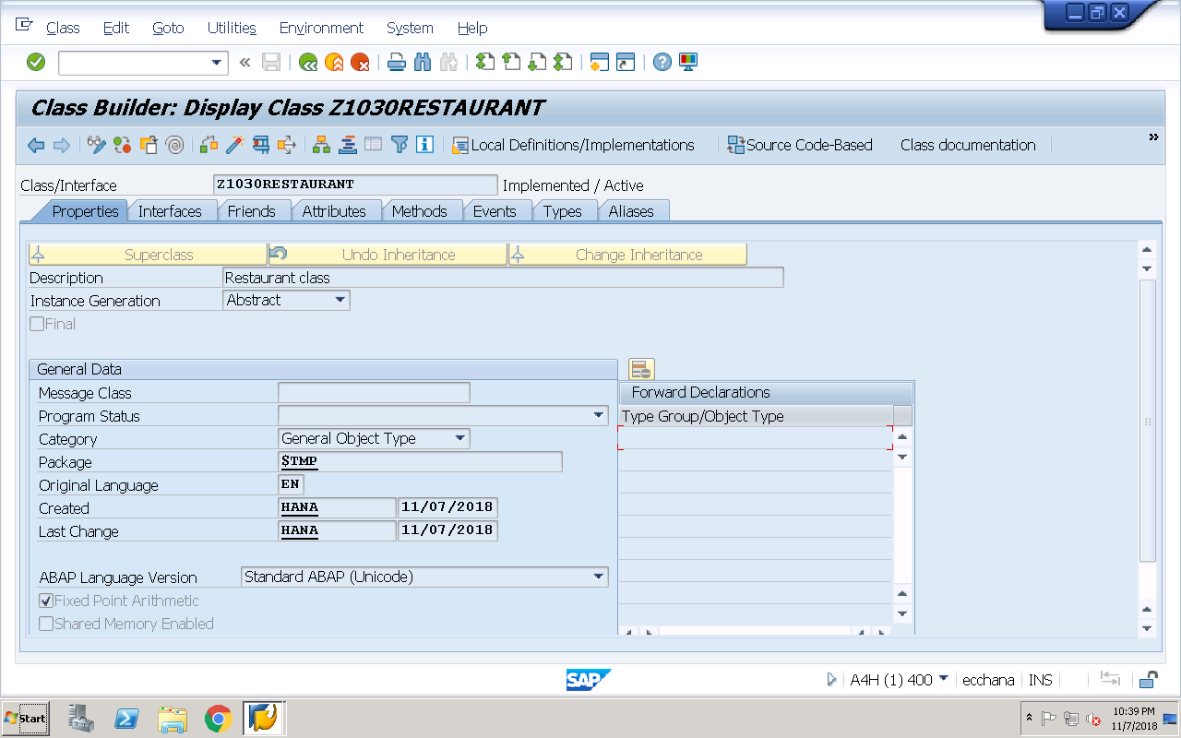
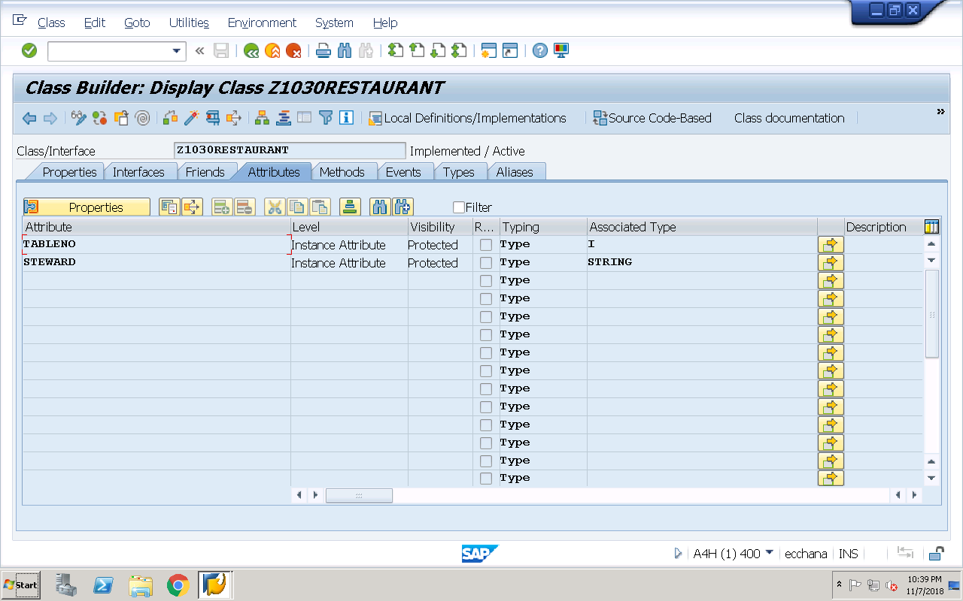
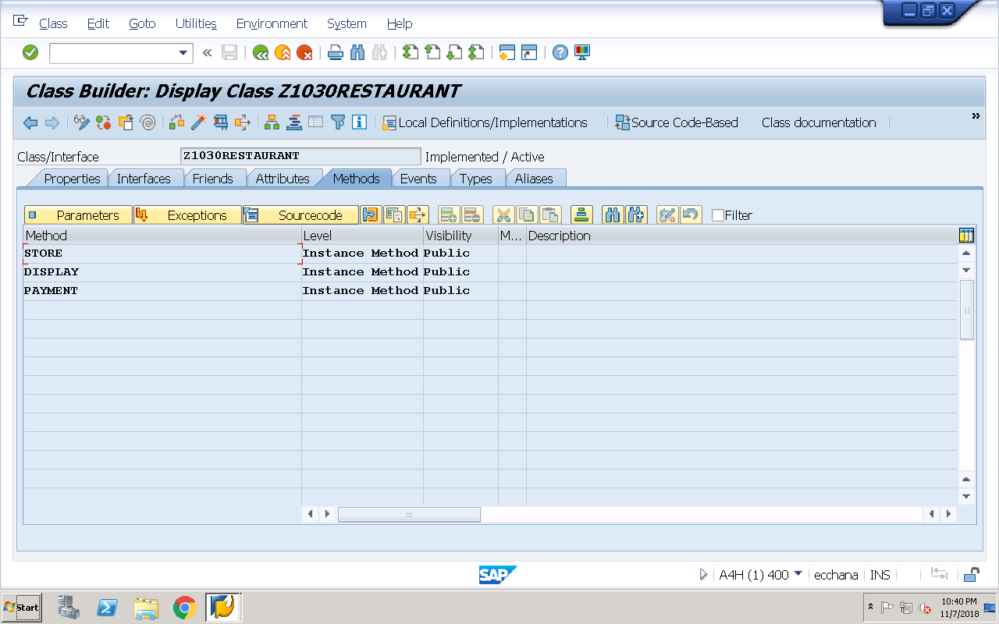
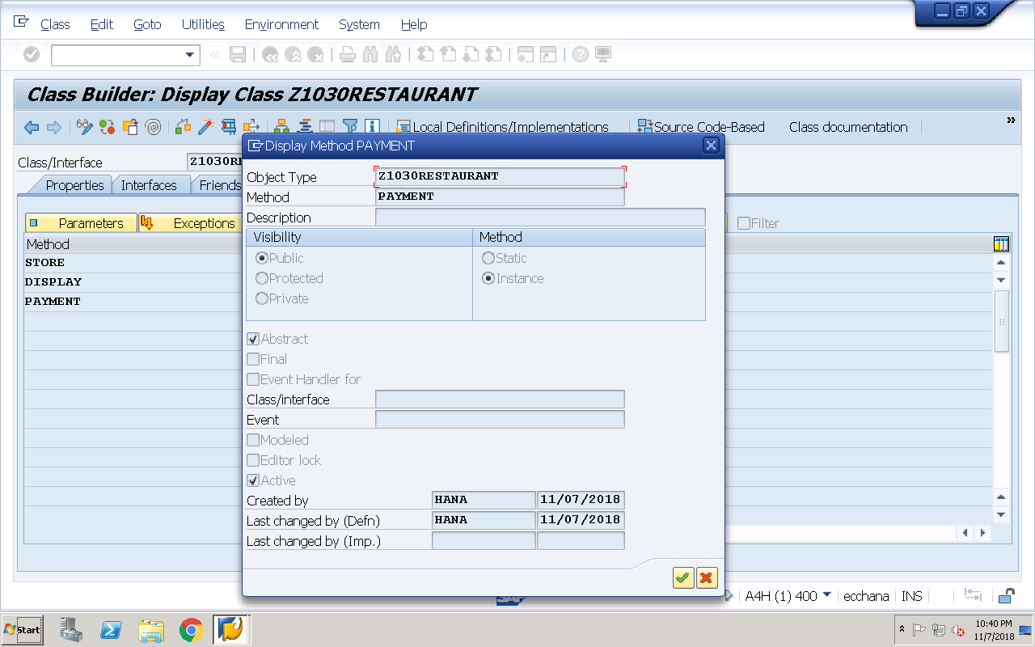
Implementation of methods:
method STORE.
tableno = 3.
steward = 'ABC'.
endmethod.
method DISPLAY.
write :/ tableno,steward.
endmethod.
Save, check and activate the above abstract class
Class ‘z1030cheque’ inheriting from abstract class ‘z1030restaurant’
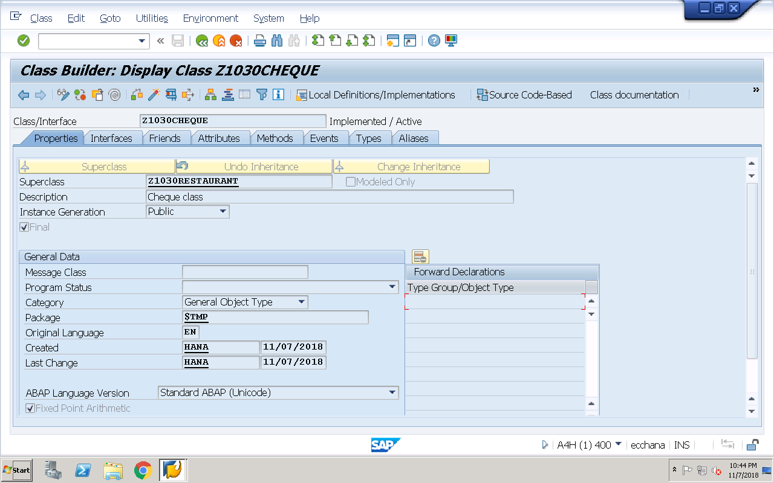
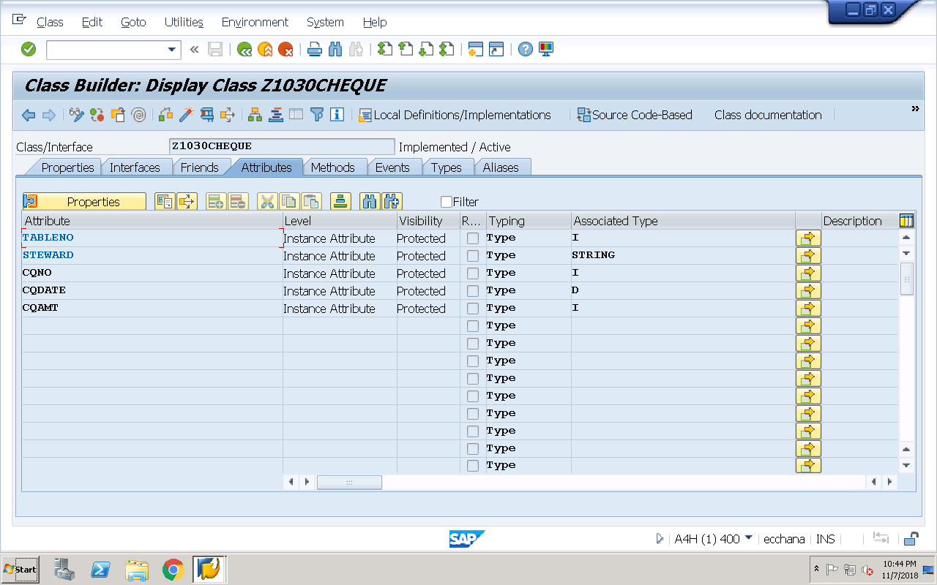
Redefine the abstract method ‘payment’:
method PAYMENT.
cqno = 123.
cqdate = sy-datum.
cqamt = 455.
write :/ 'Details of Cheque :',cqno,cqdate,cqamt.
endmethod.
Save, check and activate the above class
Class ‘z1030creditcard’ inheriting from abstract class ‘z1030restaurant’
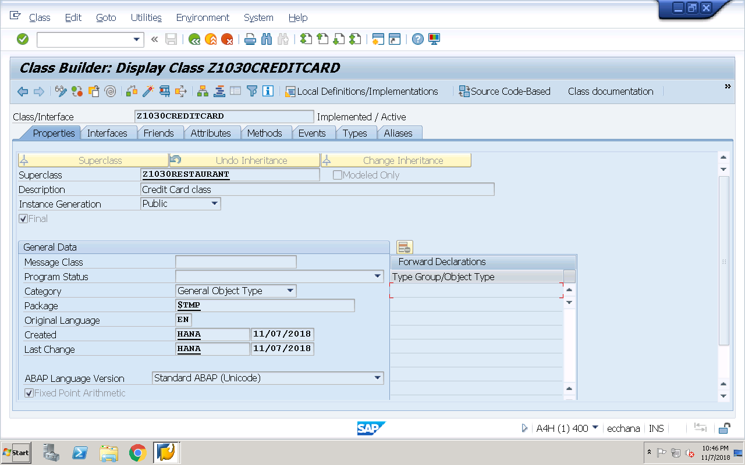
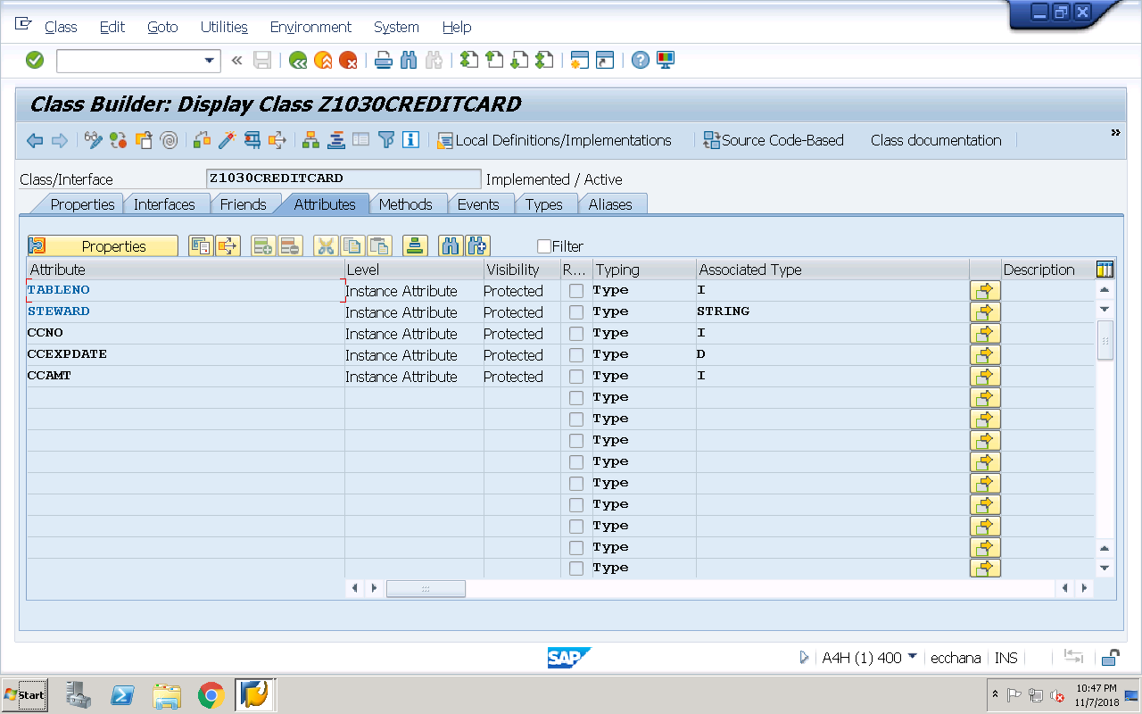
Redefine the abstract method ‘payment’
method PAYMENT.
ccno = 455.
ccexpdate = sy-datum.
ccamt = 234.
write :/ 'Credit card details :',ccno,ccexpdate,ccamt.
endmethod.
Save, check and activate the above class
Executable Program:
REPORT Z1030OOPS33.
data r type ref to z1030restaurant.
*create object r. "syntax error
data cq type ref to z1030cheque.
create object cq.
format color 3.
write :/ 'Using Cheque clas object....'.
call method : cq->store,
cq->display,
cq->payment.
r = cq. "narrow casting
format color 7.
write :/ ' Cheque clas object assigned to restaurant....'.
call method : r->store,
r->display,
r->payment.
uline.
format color 1.
write :/ 'CREDIT CARD Object....'.
data cc type ref to z1030creditcard.
create object cc.
call method : cc->store,
cc->display,
cc->payment.
r = cc. "narrow casting
format color 2.
write :/ ' Credit card class object assigned to restaurant....'.
call method : r->store,
r->display,
r->payment.
Example: Local Interfaces
REPORT Z1030OOPS34.
interface rectangle.
constants : length type i value 10,
breadth type i value 5.
methods : area,
perimeter.
endinterface.
interface square.
constants side type i value 10.
methods : area,
perimeter.
endinterface.
class lcl_impl DEFINITIOn. "implementation class
PUBLIC SECTION.
interfaces : rectangle,
square.
PROTECTED SECTION.
data res type i.
endclass.
class lcl_impl IMPLEMENTATION.
method rectangle~area.
res = rectangle~length * rectangle~breadth.
write :/ 'Area of rectangle is ',res.
endmethod.
method rectangle~perimeter.
res = 2 * ( rectangle~length * rectangle~breadth ).
write :/ 'Perimeter of rectangle is ',res.
endmethod.
method square~area.
res = square~side * square~side.
write :/ 'Area of square is ',res.
endmethod.
method square~perimeter.
res = 4 * square~side.
write :/ 'Perimeter of squareis ',res.
endmethod.
endclass.
START-OF-SELECTION.
data r type ref to rectangle.
*create object r. "syntax error
write :/ 'Implementation class object ob...'.
data ob type ref to lcl_impl.
create object ob.
call method : ob->rectangle~area,
ob->rectangle~perimeter.
uline.
write :/ 'Implementation class object ob --> assigned to interface rectangle reference r.'.
r = ob. "narrow casting
call method : r->area,
r->perimeter.
uline.
data s type ref to square.
*create object s. "syntax error
write :/ 'Implementation class object ob...'.
call method : ob->square~area,
ob->square~perimeter.
uline.
write :/ 'Implementation class object ob --> assigned to interface square reference s.'.
s = ob. "narrow casting
call method : s->area,
s->perimeter.
Example: Global Interfaces
Global Interface ‘Z1030RECTANGLE’
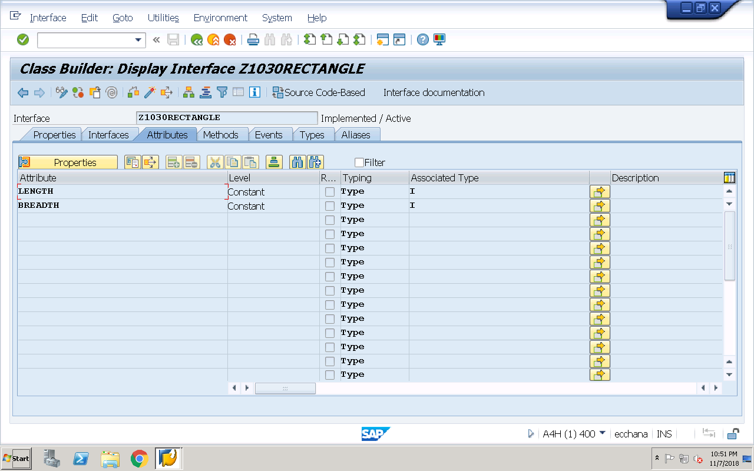
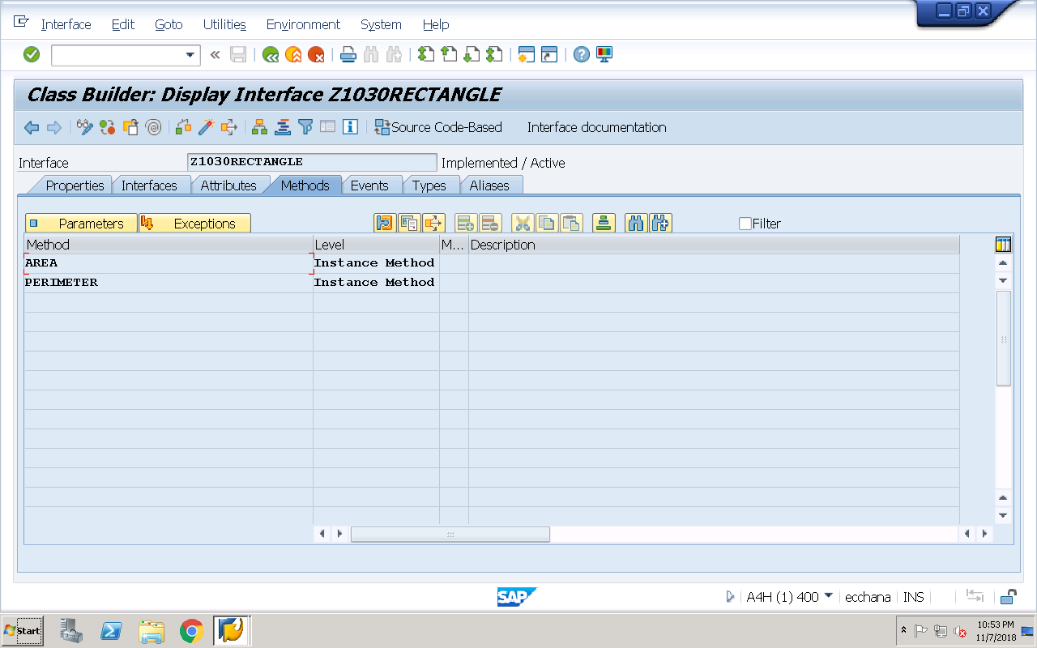

Global Interface ‘Z1030SQUARE’
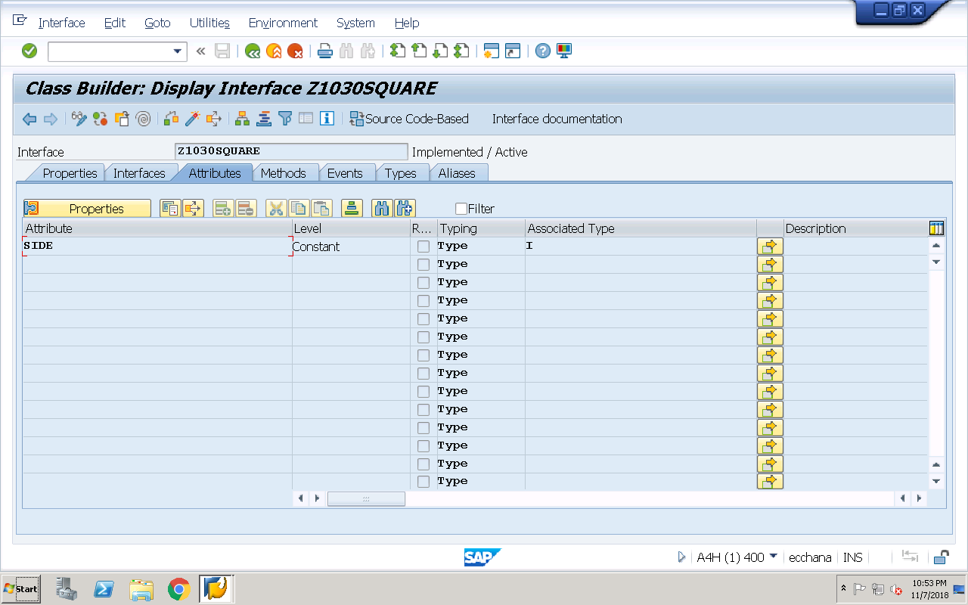
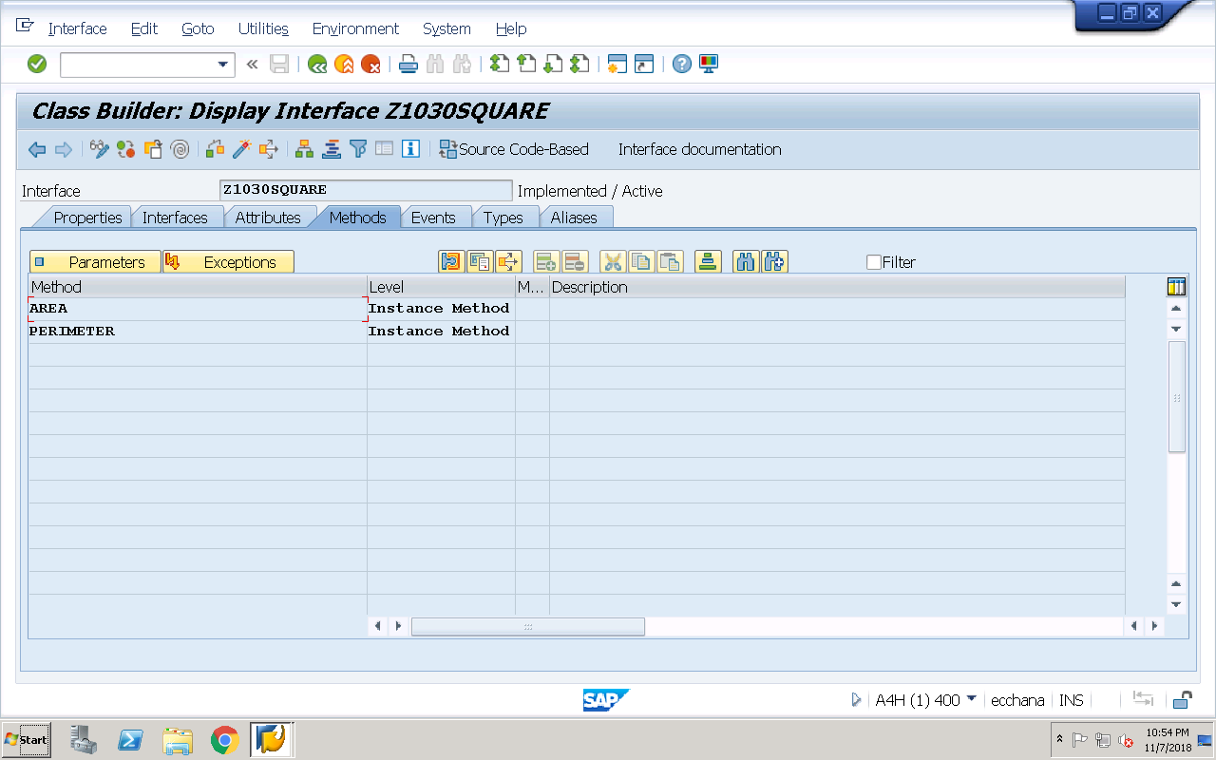

Global Implementation class implementing above 2 global interfaces
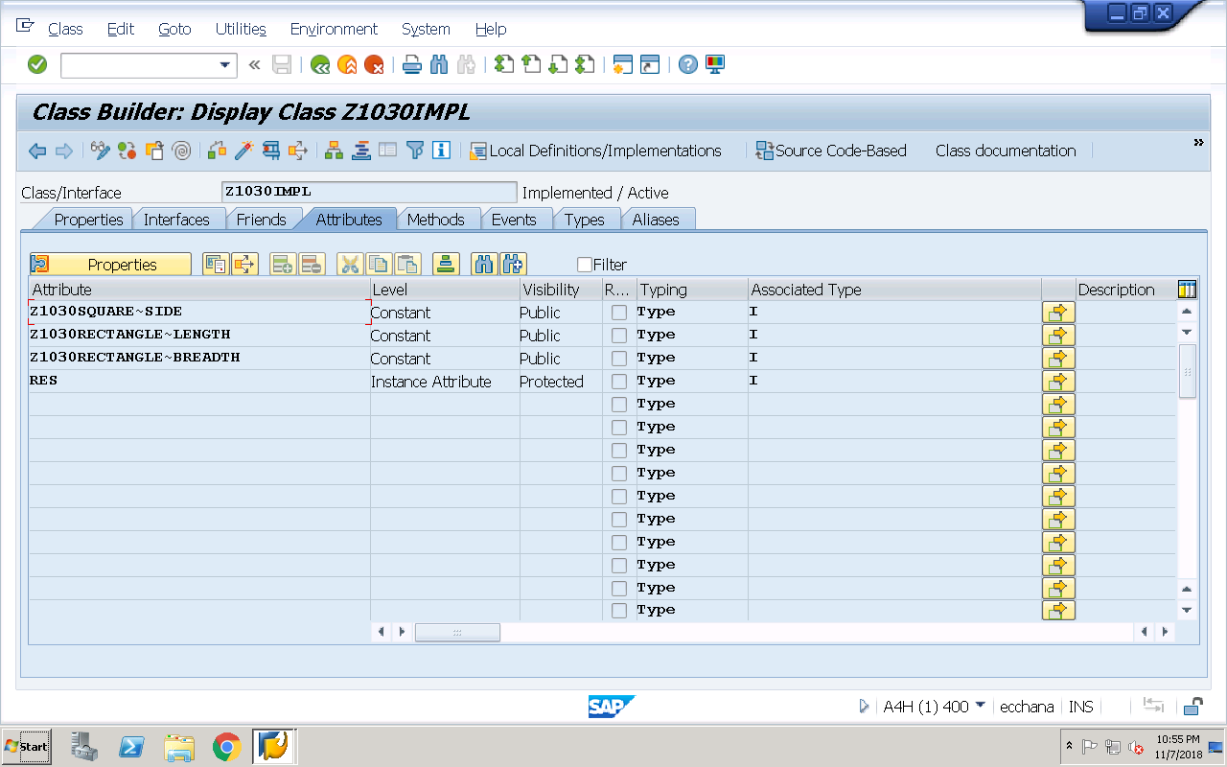

Implementation of interface methods:
method Z1030SQUARE~AREA.
res = z1030square~side * z1030square~side.
write :/ 'Area of square is ',res.
endmethod.
method Z1030SQUARE~PERIMETER.
res = 4 * z1030square~side.
write :/ 'Perimeter of squareis ',res.
endmethod.
method Z1030RECTANGLE~AREA.
res = z1030rectangle~length * z1030rectangle~breadth.
write :/ 'Area of rectangle is ',res.
endmethod.
method Z1030RECTANGLE~PERIMETER.
res = 2 * ( z1030rectangle~length * z1030rectangle~breadth ).
write :/ 'Perimeter of rectangle is ',res.
endmethod.
Executable program: Accessing above interface components
REPORT Z1030OOPS35.
data r type ref to z1030rectangle.
*create object r. "syntax error
write :/ 'Implementation class object ob...'.
data ob type ref to z1030impl.
create object ob.
call method : ob->z1030rectangle~area,
ob->z1030rectangle~perimeter.
uline.
write :/ 'Implementation class object ob --> assigned to interface rectangle reference r.'.
r = ob. "narrow casting
call method : r->area,
r->perimeter.
uline.
data s type ref to z1030square.
*create object s. "syntax error
write :/ 'Implementation class object ob...'.
call method : ob->z1030square~area,
ob->z1030square~perimeter.
uline.
write :/ 'Implementation class object ob --> assigned to interface square reference s.'.
s = ob. "narrow casting
call method : s->area,
s->perimeter.

